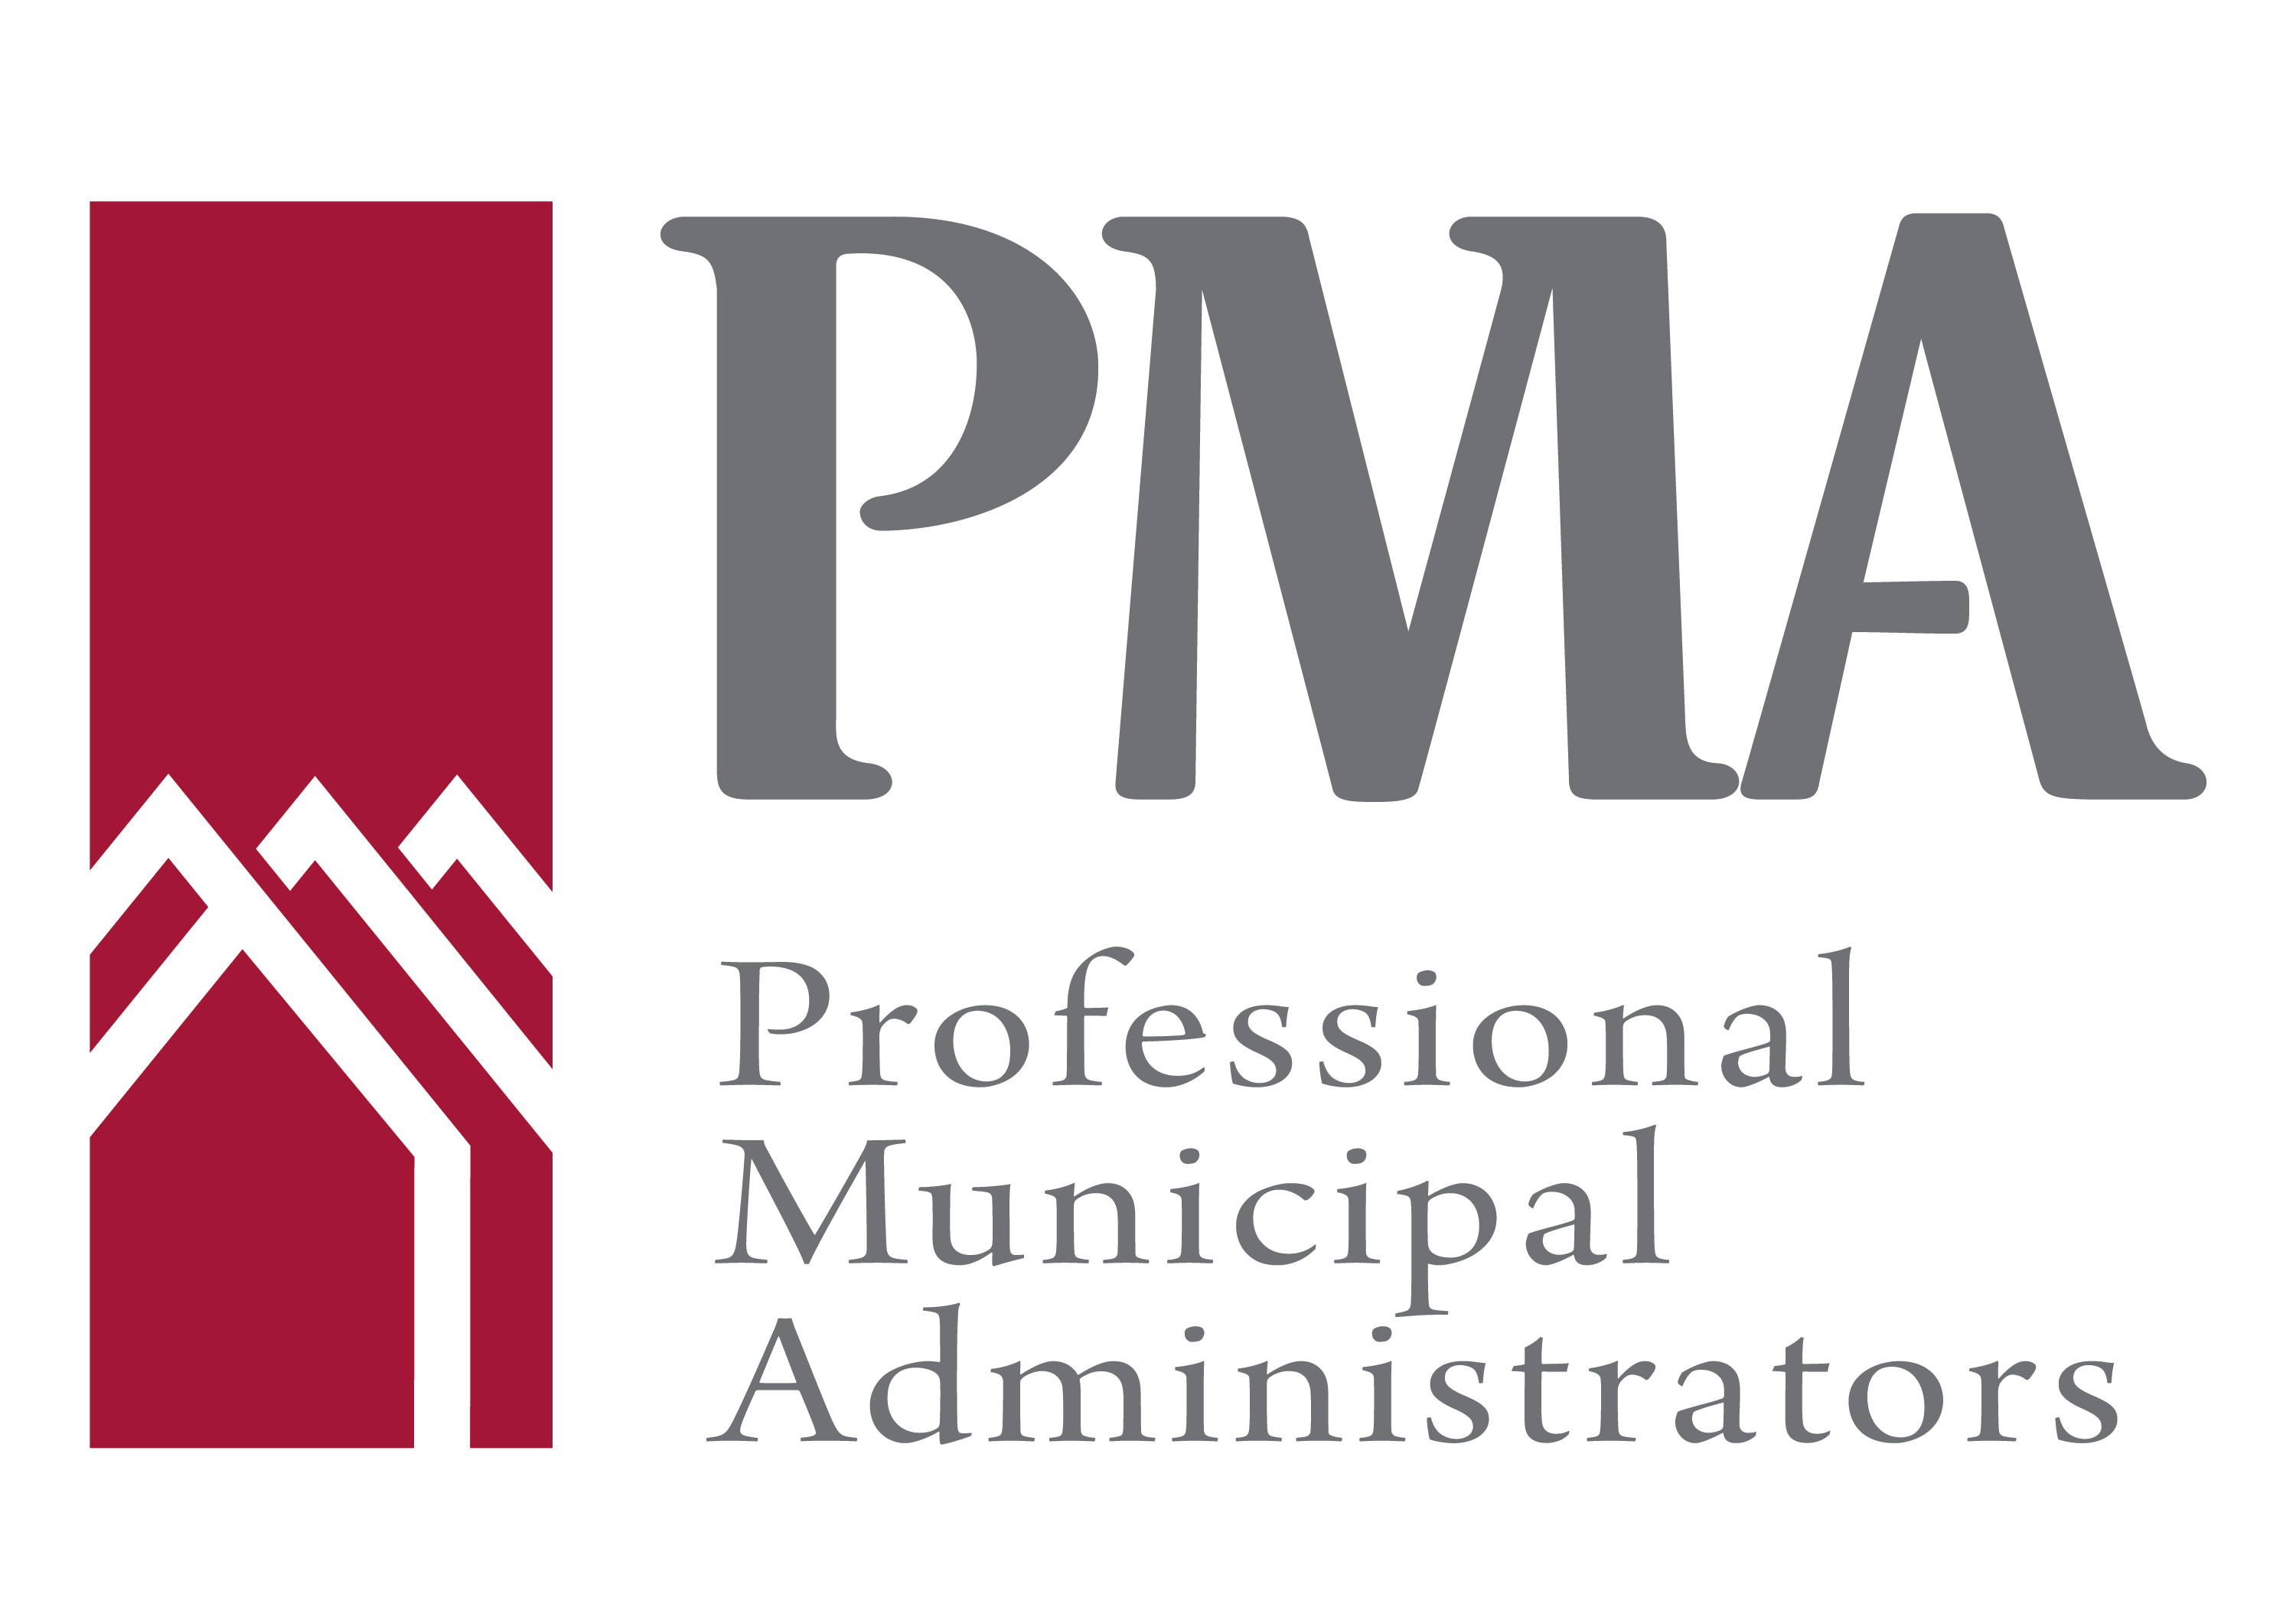
2024 BOARD MEMBER NOMINATION FORM

Nominations are being accepted for the Central Director position on the Executive of the Board.
Please note that this position is for a one year term.

We, the undersigned, hereby nominate:

Nominee’s Name: __________________________________________________________
Administrative Position: _____________________________________________________

From the Municipality of: ____________________________________________________

For the office of ______________________________________,on the Board of Directors of
Professional Municipal Administrators.

Dated this _____________ day of __________________, 2024 at _________________________

Moved By:

Name: _________________________________________________________________________________________
Position: ______________________________________________________________________________________
Municipality: _________________________________________________________________________________
Signature: ____________________________________________________________________________________
Witness: ______________________________________________________________________________________

Seconded By:

Name: _________________________________________________________________________________________
Position: ______________________________________________________________________________________
Municipality: _________________________________________________________________________________
Signature: ____________________________________________________________________________________
Witness: ______________________________________________________________________________________

I, ________________________________________________________accept the above nomination.
(Please print your name)

Signature: ___________________________________________ Date:
For PMA members not currently holding Board positions:
Deadline for nominations to be received is March 21, 2024

For sitting Directors seeking nomination for a different Board position: Deadline for nominations to be received is March 2, 2024

Email nomination form to Tammy@PMANL.ca

